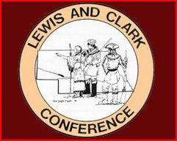

MEMBER SCHOOLS

Lewis Division

Allen

Emerson-Hubbard

Homer

Laurel-Concord-Coleridge

Ponca

Wakefield

Walthill

Winnebago

Clark Division

Bloomfield

Creighton

Hartington-Newcastle

Osmond

Plainview

Randolph

Wausa

Winside

Wynot

